Egocentric Action Recognition

**Teaching Assistants:**

Chiara Plizzari (chiara.plizzari[@polito.it](mailto:antonio.tavera@polito.it)),

Simone Alberto Peirone ([simone.peirone@polito.it](mailto:simone.peirone@polito.it))



Egocentric action recognition refers to the task of **recognizing actions performed by an individual in the first-person perspective**, i.e. from the viewpoint of the person carrying out the action. It is different from third-person action recognition, which is performed from a viewpoint outside of the person carrying out the action.

Egocentric action recognition is a challenging problem in computer vision, as the camera viewpoint changes dynamically as the person moves and performs actions. The recognition of actions from egocentric videos can have various applications, including human-computer interaction, robotics, and sports analysis.

Egocentric action recognition still has one major challenge, known as ``environmental bias”. This problem arises from the network's heavy reliance on the environment in which the activities are recorded, which inhibits the network's ability to recognize actions when they are conducted in unfamiliar (unseen) surroundings. **Domain adaptation** aims to reduce this problem, which is referred to as domain shift, by learning domain-invariant representations that can generalize well to the target domain.

The main objective of this project is to become familiar with Egocentric Action Recognition (EAR).

The project then divides into two different variants, the **first one** consisting in moving towards new modalities enabled by wearable sensors, e.g., EMG signals measuring the wearer's muscle activity, and the **second one** explores Domain Adaptation techniques for Egocentric Action Recognition.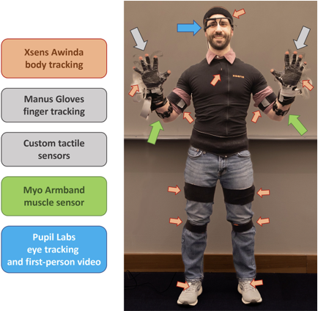

1. **Multi-modal Egocentric Action Recognition**

**Task:** Multi-modal Egocentric Action Recognition

**Challenges:** implementation of a multi-modal model using RGB frames and EMG signals measuring the wearer's muscle activity and learn to reconstruct the EMG signal when only RGB is available.

**2. Egocentric Action Recognition**

**Task**: Domain Adaptation for Egocentric Action Recognition

**Challenges**: the project consists in the implementation and testing of a popular Domain Adaptation technique, and in the development of a new one and/or a **participation in the EK-UDA challenge**. Find out more @ [link](https://github.com/epic-kitchens/C4-UDA-for-Action-Recognition).

[1] DelPreto, Joseph, et al. "ActionNet: A Multimodal Dataset for Human Activities Using Wearable Sensors in a Kitchen Environment." NeurIPS22

[2] Damen, Dima, et al. "Scaling egocentric vision: The epic-kitchens dataset." ECCV 2018.